1. **Agenda**:Text

   Description automatically generated
   1. We’re going to verify that whatever we have configured is being called or not.
2. Verifying whether a request to a URL was made to WireMock Server or not.
3. **Failed Case**:   
   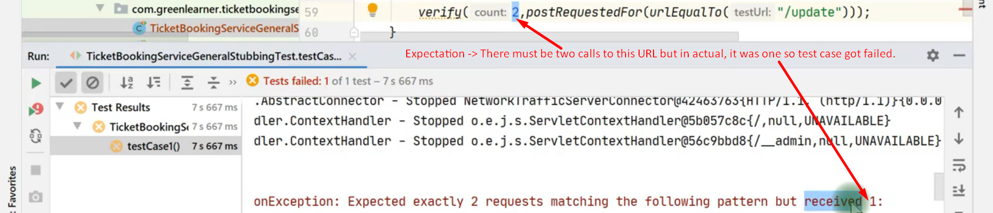  
   Start from here:   
   https://youtu.be/akHae3jXDyQ?list=PLq3uEqRnr_2FKs8K3_kIG9g93Uy9dVdtR&t=258